Feasibility Model Design

F2019 – Edit this document into a deliverable.

|  |  |  |  |
| --- | --- | --- | --- |
| Lab Section: | 3 | Group: | 1 |

# System-Level Design

Our ECE 298 projects start with a conceptual architecture, like the block diagram in Figure 1a). Specific example in Figure 1b). **Replace this figure with a high-level block diagram of your system.**

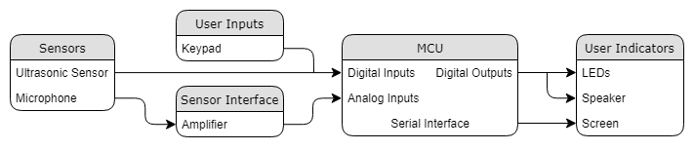

## Project Design Requirements

In PD 21 you learned about engineering requirements. They fall into three major categories, as follows:

1. **Functional requirements** are quantities that specify the performance of a design. They are related to the functions of the design, identified as answers to the question, "What does it do?" For example, a functional requirement for a coffee maker may specify the time required to brew a pot of coffee, a DC power supply may specify its maximum voltage, and a vehicle alarm system may specify how much noise it makes when it is set off
2. **Non-functional requirements** specify characteristics of the design that are not performance based. Theses are typically features or qualities that are desirable to the client. For example, ease of use, ease of manufacturing, and use of recycled materials.
3. **Constraint requirements** place limits on the design space, and often reflect budget or other project limitations. For example, cost, weight, and noise.

The basic form of most of these requirements is the same: a short description, followed by a relationship (equals, less than, or greater than) and a value.

**State three to five major Functional Requirements that your project must meet to successfully solve your problem statement.**

1. The security system continually monitors at least 4 different zones.
2. Entry and exit sensors detect doors being opened in less than 1 second.
3. The number of zones that can detect noise is at least 1.
4. The alarm noise is greater than 50 dB when it is triggered.
5. The alarm is armed less than 1 second after the correct PIN is entered.

## Project Sensors and User Inputs

* List the types of sensors and user inputs you may require (light, sound, temperature, magnetic field).

1. Sound (Mic) to detect intruders
2. Ultrasonic to detect doors and windows being opened
3. Keypad to arm the alarm

* For each sensor and user input, list how you will connect it to the MCU, including additional interface components, if needed.

1. The mic will go through an amplifier than will then connect to the MCU as an analog input.
2. The ultrasonic sensor will be powered by connecting it to 5 V and GND pins of the MCU. The MCU will output a trigger pulse to the sensor, and the sensor will return an echo pulse as an input to the MCU.
3. The MCU will output 3 different signals for each column of the keypad and will receive 3 input signals that correspond to each row of the keypad in order to detect which button is pressed.

## Project Actuators and Indicators

* List the types of actuators and indicators you may require (e.g. light, sound, mechanical motion)

1. Lights
2. Sound
3. Screen

* For each actuator and indicator, list how you will connect it to the MCU, including additional interface components, if needed.

1. The MCU will output directly to the LEDs in series with a resistor.
2. The MCU will output directly to the audio transducer.
3. The screen is already connected to the MCU.

## Project MCU Peripherals

* List the resources inside the MCU that could be used to implement your project (e.g. ADC, timers, interrupts, GPIO functions).

1. Timer to act as a time reference
2. Interrupts to trigger alarms
3. ADC to read in the mic voltage
4. GPIO to output to the LEDs and ultrasonic sensors, as well as to read in the keypad presses and ultrasonic sensors
5. PWM to output to the audio transducer

* List parameters that the software running on the MCU might require.
  1. Ultrasonic sensor distance
  2. Mic volume

## Project Testing Methodology

* For each sensor, user input, actuator, indicator, and MCU peripheral listed above, state how you will verify that each one is functioning as expected (a table may be helpful)

|  |  |
| --- | --- |
| **Component** | **Test Method** |
| Mic | Produce some noise and indicate noise is detected on screen |
| Ultrasonic | Place object in front of sensor to read an initial distance, then move object back and verify distance changes |
| Keypad | Enter numbers on keypad and output onto screen |
| LEDs | Output to LED and verify they illuminate |
| Speaker | Output to speaker and verify it produces sound |
| Screen | Output values to screen and verify they appear |

* State how you will validate that each Project Design Requirement has been met

|  |  |
| --- | --- |
| **Requirement** | **Validation** |
| 1 | Trigger the alarm in each zone |
| 2 | Measure the time between a door/window opening and the alarm sounding |
| 3 | Trigger the alarm in one zone by making noise |
| 4 | Measure the speaker sound when the alarm is triggered |
| 5 | Measure the time between alarm arming and alarm state becoming armed |

# Feasibility Model Diagram and Software Flowchart (High-Level)

A simplified example is shown in Figure 2 and Figure 3. **Replace these figures with high-level block diagrams of your system.**

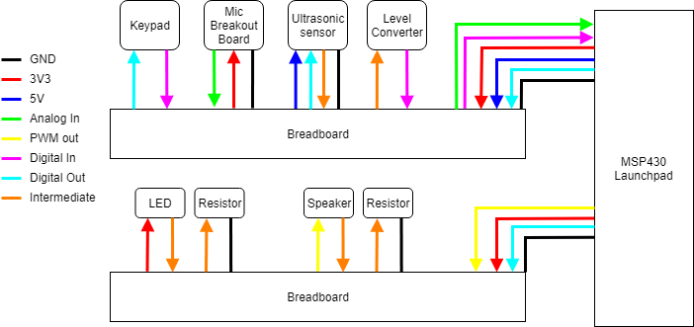

Figure : Simple Sketch of a Feasibility Model Design

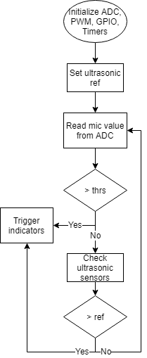

Figure : Simple Sketch of a Software Flowchart

## Initial Bill of Materials

* List what modules and components (including quantities) are needed from the ECE 298 Parts spreadsheet for your Feasibility Model Design

|  |  |
| --- | --- |
| **Module/Component** | **Quantity** |
| Mic & amp breakout board | 1 |
| Audio transducer | 1 |
| Keypad | 1 |
| Red LED | 4 |
| Green LED | 4 |
| Ultrasonic sensor | 4 |